Project Title: Food Nutrition Estimator from Image and Text using AI

Research /Project Area : Artificial Intelligence/Machine Learning.
Abstract :
This project introduces the concept to implement LiveFit—a smart algorithm designed from AI, that would help users improve the accuracy (precision), speed as well as customization of dietary tracking. The proposed framework applies a Vision Transformer-based food recognition model for real-time image classification, IFCT and USDA databases to obtain accurate nutrition status and Google Gemini 2.5 Flash for intelligent conversation with dietary suggestions. The React Native-based interface allows seamless user interactions while its Flask backend and MongoDB Atlas provide secure data handling, synchronization. The system also contains a gamification of the reward system, with Razorpay added to make user engagement more intense. The app integrates both text and image-based food input, real-time calculations on calorie counts, and tailored nutrition monitoring to ensure compatibility with user actions and dietary knowledge. Experimental analysis indicated a strong increase in food identification accuracy and user's task completion rate and decrease in manual logging effort.

Prototype / Systemwork flow:
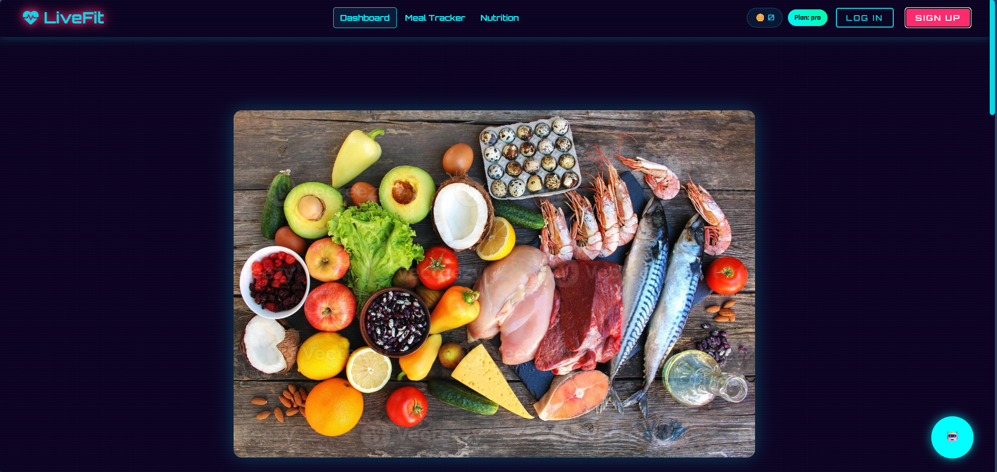

Name of Student(s) : Aryan Walia, Kushagra Pankaj, Subham Prasad Achary
Programe(s): B. Tech. – CSE (Specialization in IoT, Cyber Security & Blockchain Tech.)
Name of Supervisor(s) : Dr. Roshan Lal
Relevant Publication / Patent / Copyright:
Aryan Walia, Subham Prasad Achary, Kushagra Pankaj and Roshan Lal, " An AI-Driven Personalized Nutrition, Meal Planning, and Subscription Based Health Ecosystem," International conference on advance in Multidisciplinary Engineering (ICRAME 2026) at Maharishi University of Information Technology, Lucknow, India.

